STAT8122 Time Series

Assignment 1

44588070

Load in libraries

**Question 1**

**Minimum Temperature Observatory Hill**

The minimum daily temperature does not seem to have a trend, seeing that the average looks fairly consistent. There seems to be a little bit of seasonal pattern throughout each year, but it is hard to see from this graph so we will try to view a year period.

After examining the year 1940, it confirms that there is some seasonality within the data. It appears that during the summer the minimum temperature is a lot higher than the winter. Both have similar variance.

The gg_season plot also confirms that there is a seasonality across all years with no trend due to the data following the same pattern each year with similar variance.

It is hard to make out the average seasonal daily pattern from this graph. It is also hard to see the blue lines from the graph due to their being 365 days in a year.



The gg_lag plot shows that there is a strong positive correlation between the lagged variable and the original variable.

The ACF plot shows the seasonality over the 760-day period, which shows seasonality if we lag by a period of 2 years.

***Maximum Temperature Observatory Hill***

The maximum daily temperature does not seem to have a trend seeing that the average looks fairly consistent. There seems to be a little bit of seasonal pattern throughout each year, but it is hard to see from this graph so will try view a year period.

After examining the year 1940, it confirms that there is some seasonality within the data. It appears that during the summer the minimum temperature is a lot higher than the winter. Both have similar variance.

The gg_season plot also confirms that there is a seasonality across all years with no trend due to the data following the same pattern each year with similar variance.

The graph is difficult to make out the average seasonal daily pattern. It is hard to see the blue lines from the graph.

The gg_lag plot shows that there is a strong positive correlation between the lagged variable and the original variable.

The ACF plot shows the seasonality for the over the 760-day period which shows seasonality if we lag by a period of 2 years.

**Rainfall Amount (Millimetres) Sydney Botanical Gardens Daily Rainfall**

The amount of daily rainfall does not appear to have any trend as the majority of the graph seems to average quite low around 30ml with heaps of spikes.

After examining between the years 2000-2010, there does not appear to be a trend or seasonality in the plot for daily rainfall. It seems that regardless of the month it is fairly random.

The gg_season plot doesn’t seem to reveal any trend or seasonality as a lot of the days have similar variance and average daily rainfall.

It is difficult to make out the average daily pattern. It is also hard to see the blue lines from the graph due to it being a 365-day period.

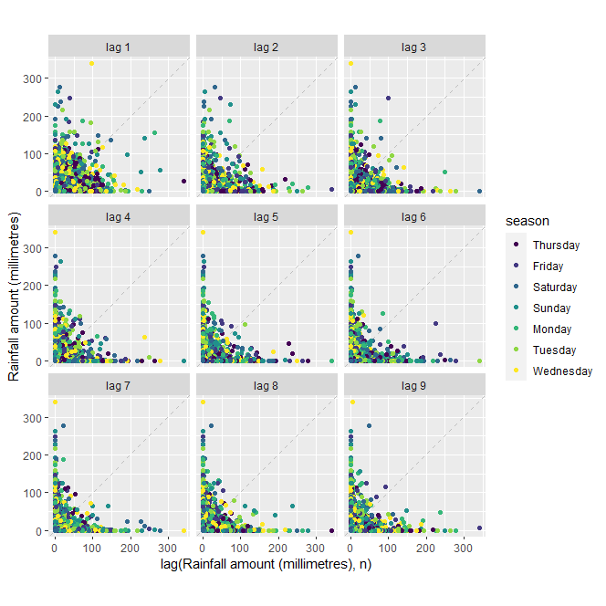

The gg_lag plot seems to show a low correlation between the lagged variables and the original variable.

The acf plot does not seem to show seasonality. The daily rainfall seems to be fairly random. If the acf plot stays within the blue lines, then it would be considered white noise.

**Question 2**

1. **Rainfall Sydney Botanical Gardens Monthly Rainfall**

The auto plot for monthly data looks significantly different than the daily data due to daily rainfall being summed together. There are less zero values, and it looks like there is a small seasonality effect.

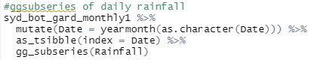

The gg_subseries shows the highest average rainfall happens within the first half of the year, while the later months from July-December have a similar average slightly lower than that from January-June. This would make sense due to summer being the hotter and earlier months of the year. As summers are hotter this would result in more water being evaporated.

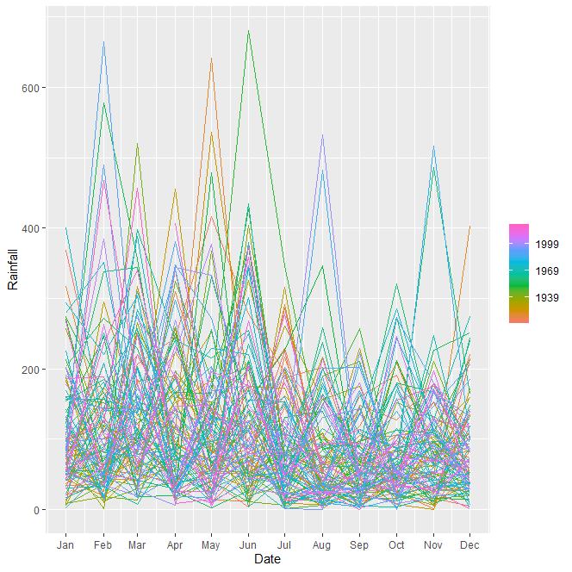

There is a lot of noise within the gg_season plot making it hard to see a seasonal pattern. There seems to be larger spikes in the months from January-June. This also agrees with the possibility that summer months rain more than others.

1. **STL decomposition of monthly rainfall**

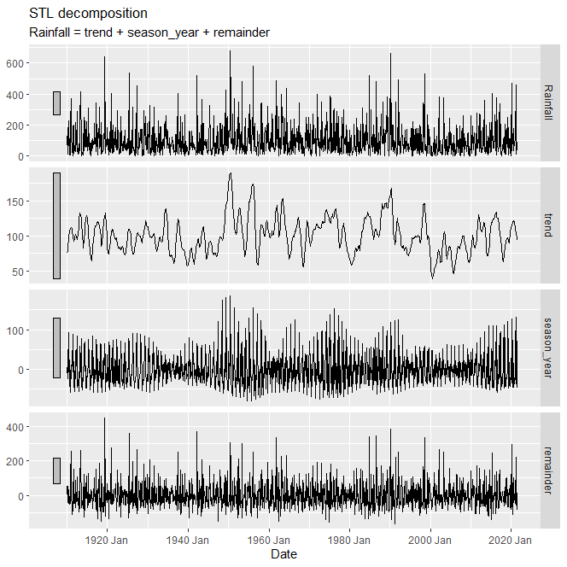

This STL decomposition shows how average monthly rainfall for the Sydney Botanical Gardens can be decomposed into trend, seasonality, and remainder. The trend captured seems to have a similar average on a year-by-year basis with a couple of years having a lot more volatility. This could be due to other weather patterns such as climate patterns. The trend has the same scale as the data as this component has the smallest contribution to the data (has the largest grey bar). The seasonal plot varies slightly throughout the series. The seasonality component is the second biggest component (as the grey bar is slightly smaller than the trend and bigger than the remainder). Lastly the remainder seems to be the biggest contributor to the data as the spikes in the remainder seem to mimic the large spikes within the data. This would likely show the effect of other variables contributing to the change in rainfall.

1. **How does the seasonal shape change over time?**



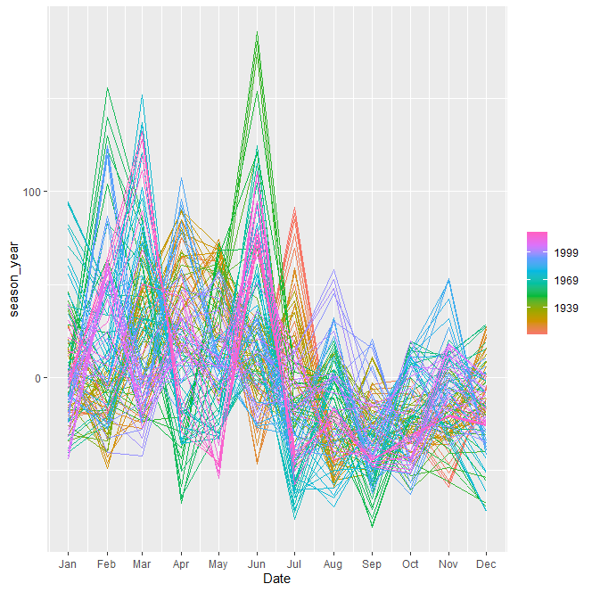

This graph is still fairly difficult to see the seasonality as it is hard to distinguish the years, however it is clear that the summer period till June has higher rainfall with a higher volatility. The later months from July to December have significantly less rainfall with less volatility.

1. **Can you produce a plausible seasonally adjusted series**

This chart shows the season adjusted (blue line) compared to the original plot (black line). The seasonal adjusted series reduces some of the variance by removing the variation attributed to seasonality.